Solving Quadratic Equations Using Socratic AI
Md Al Amin-2232278020

Introduction
Socratic by Google is an AI-powered educational tool that helps students solve academic problems by using text or image input. It is mainly used for subjects like mathematics, science, literature, and history. Students can simply take a picture of a question, and the AI provides step-by-step explanations and solutions. This AI is useful because it saves time and helps students understand difficult concepts more easily. I used this AI to solve a quadratic equation problem and observe how accurately it explains the solution process.

Prompt
Input Prompt Given to the AI
I uploaded an image containing the quadratic equation:

Optional Inputs
- Image upload feature
- Mathematical problem-solving mode
- Step-by-step explanation enabled

Output
The AI identified the equation correctly and solved it using the factoring method.
AI Solution
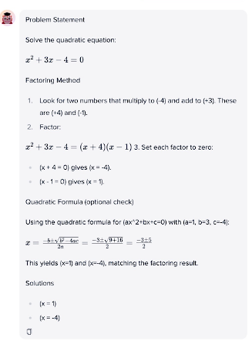
The AI also verified the answer using the quadratic formula.

Describe Your Output
The output generated by Socratic AI was accurate and clearly organized. The AI not only provided the correct answers but also explained every step in a simple manner. It used both the factoring method and quadratic formula, which helped verify the solution. The explanation was easy to understand for students learning algebra. Overall, the AI performed very effectively and produced a high-quality educational response.

Prompt Engineering
The following improvements can help generate even better outputs from this AI tool:
- Upload a clear and high-quality image of the mathematical problem.
- Include instructions like “show every step clearly” for detailed explanations.
- Mention the solving method if a specific method is required.
- Avoid unclear handwriting or cropped images.
- Use proper mathematical symbols and formatting.
- Ask follow-up questions for deeper understanding.
- Specify the educational level (school, college, beginner, etc.).
Conclusion
Socratic by Google is a very useful AI tool for students, especially for solving mathematics problems. Compared to many other AI learning tools, it is fast, easy to use, and provides step-by-step explanations through image recognition. It is particularly helpful for students who struggle with understanding mathematical procedures. However, some advanced mathematical problems may still require additional explanation from teachers or other AI tools like ChatGPT. Overall, Socratic AI is an excellent educational assistant for quick learning and problem solving.
Note
AI Used for Writing Assistance
- Socratic by Google
- ChatGPT
